EWTN Quarterly Promotion Ideas
How to Use This:
- Quarterly Planning
- Creative Insight
- Teamwork
Great promotions are like life. What do you do know is forward momentum for the next quarter. Expectation, Realization, and Memory. Tell the audience what you are giving away. Paint-a-picture. Give the prize away and let us all share in the winning experience. Remind the audience what you gave away and allow the winner to share their experience. Expectation/Realization/Memory. Side note; experiences are more memorable than a prize. Experiences change lives.
Promotional Checklist: When it comes to events … it’s all about signage. I shouldn’t be able to look in any direction without seeing your station’s presence. I should hear it on the air. You absolutely must own every event you do.
Promotions are one of the most important parts of station awareness. A station needs to be highly visible around town to be as successful as possible. Top of Mind Awareness (TOMA) is what leads to reported listening.
Promote where and how one can find your radio station. Online, on Smart Speakers, on the App, etc.
COMMUNITY INVOLVEMENT
Getting a station with organizations like St. Jude Children’s Hospital or Children’s Miracle Network, Salvation Army, The United Way, local food banks, and Toys for Tots are great ways to tug at the emotions of listeners, and it makes the on-air personalities “human” and clearly local. A station that takes every opportunity to celebrate the community in which they live will accomplish much more than other stations.

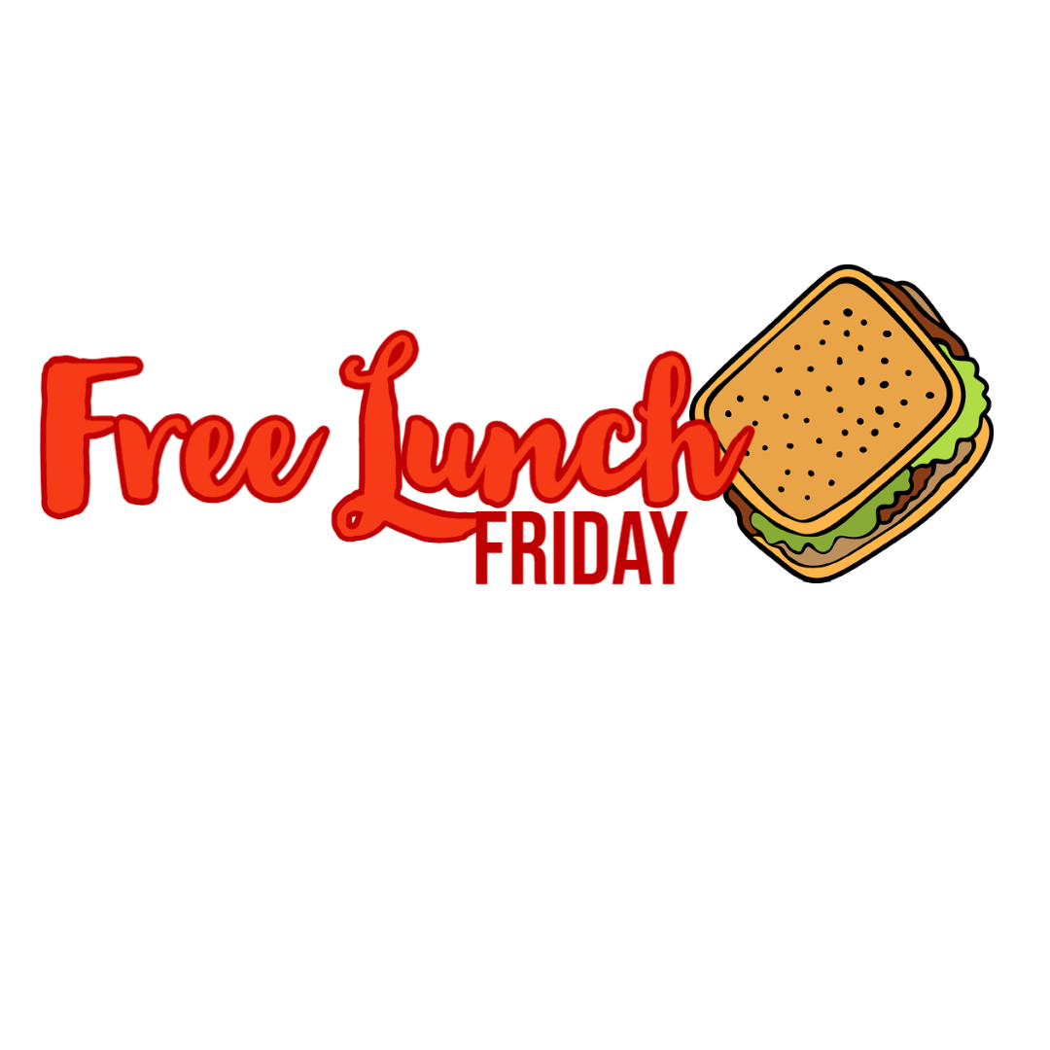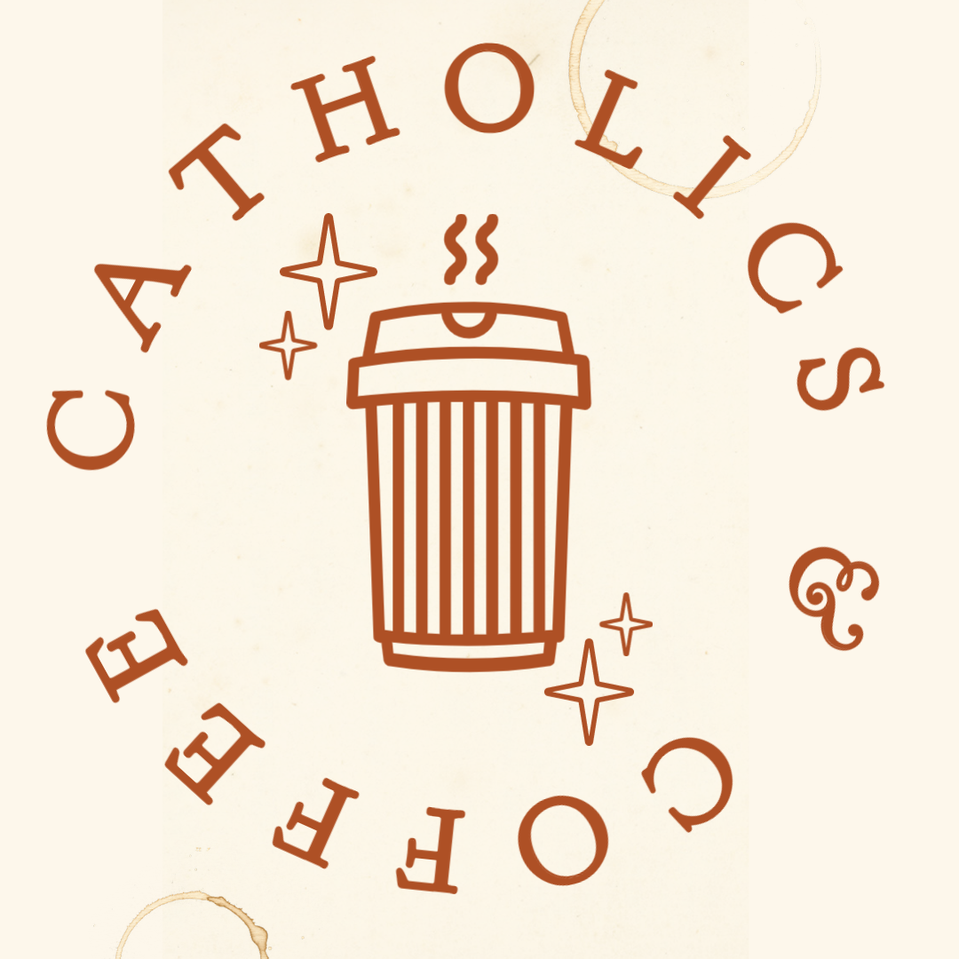
Free Lunch Friday or Catholics & Coffee
In partnership with local restaurants, you pick a local office to win free lunch or donuts & Coffee that would allow you be in front of businesses and heighten awareness of your station and maybe open doors for business partnerships.
How it works: Sign up at the web site and draw your winner once a week. Arrange to have a staff/street team member deliver the food to the winner’s office with station swag that helps spread the word about the station.
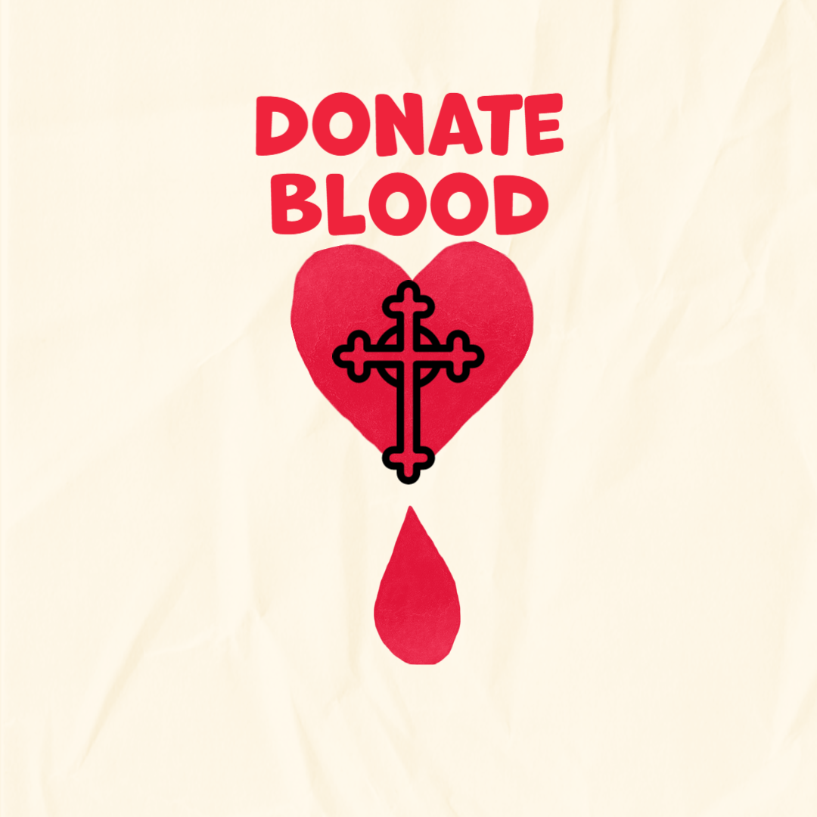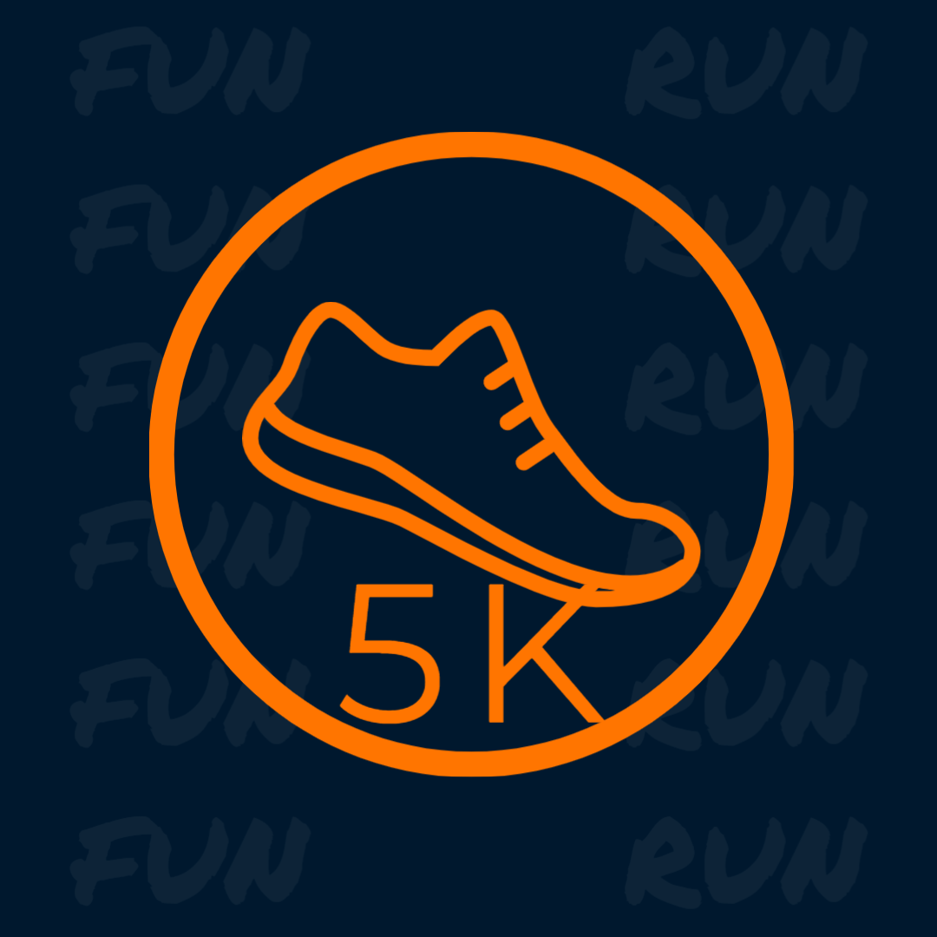
Blood Drive or 5K
In partnership with local events, you would be a partner for an event that’s already happening in the community that you can put your name on and own it as your own. There’s a lot that goes into Blood Drives and 5K runs but they are for good causes and build our community. The great thing is usually one or both are happening already and we just need to build the relationship with who is doing them and help promote it which also puts us out in front of people.
How it works: Sign up people at the web site for donation or registration and then the day of the event send staff/street team to the event and greet people as they come to participate.

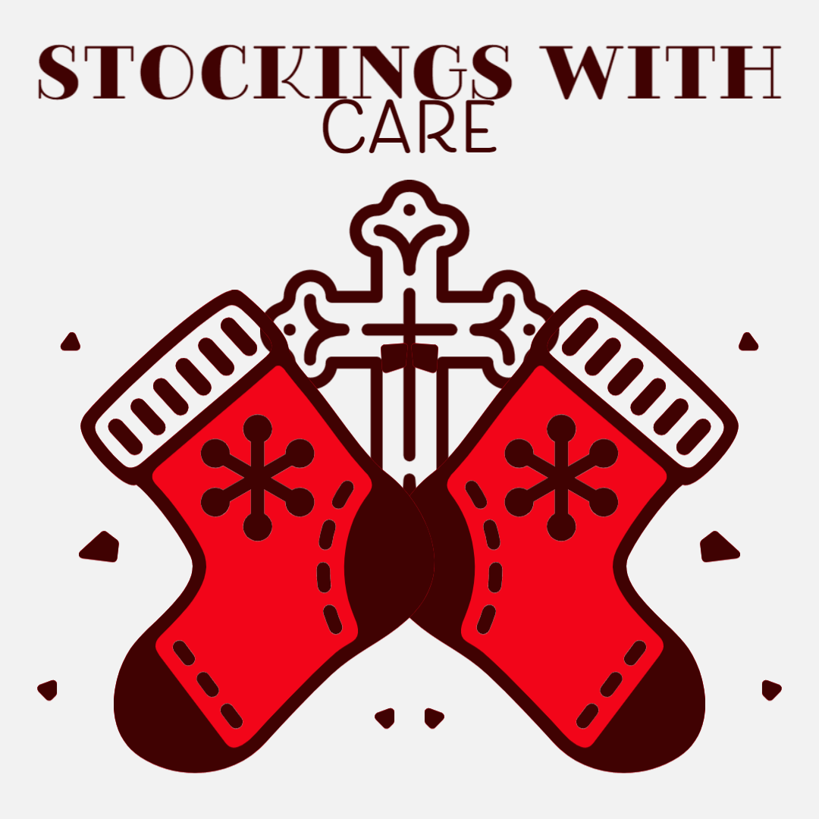
Stockings with Care
In partnership with local organizations or churches that are helping families at Christmas, you rally your audience to stuff a stocking with goodies for less fortunate kids. You could even extend it to abused and battered women.
How it works: Post on your web site with suggested items for the stockings and where people can drop them off. It could be your station or local businesses you partner with. Set a drop deadline date then collect them all and take them to the organization in time for them to distribute for Christmas.
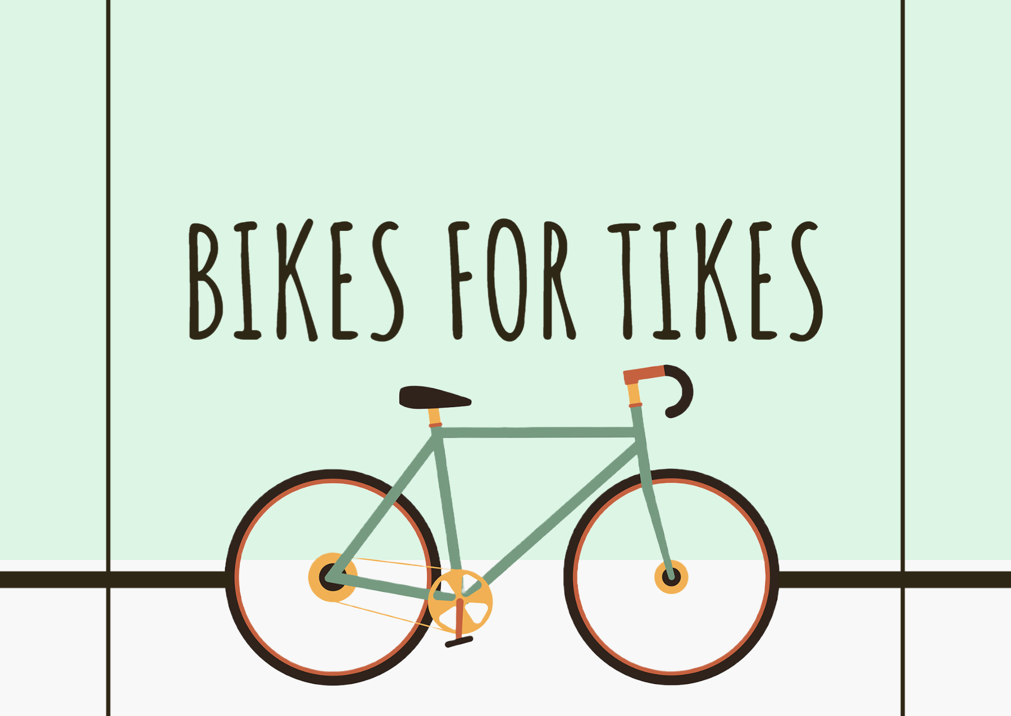
Bikes for Tikes
In partnership with local organizations or churches that are helping families at Christmas, you rally your audience to donate bikes for less fortunate kids.
How it works: Post on your web site where people can drop them off. It could be your station or local businesses you partner with. Set a drop deadline date then collect them all and take them to the organization in time for them to distribute for Christmas.

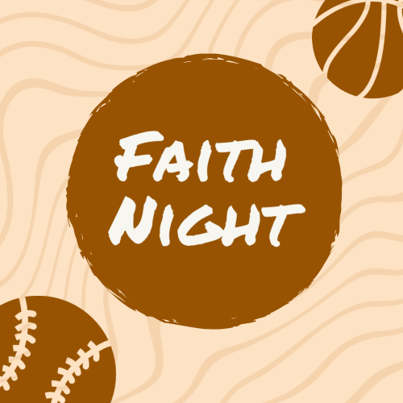
Faith Night
In partnership with local sports teams, you promote their already existing Faith Nights for church groups to get together.
How it works: Post the date of the game on your web site with a link for people to get tickets in advance at a discount rate. The teams can set that up so all you do is provide the simple way to find it. It’s trackable for the team and allows them to see the amount of audience you bring to the table. Also, you would set up a table at the game and have staff/street team meet people and hand out station swag to let them know more about your station. You could even find players who are willing to share their catholic faith on the air to help engage the audience even more.
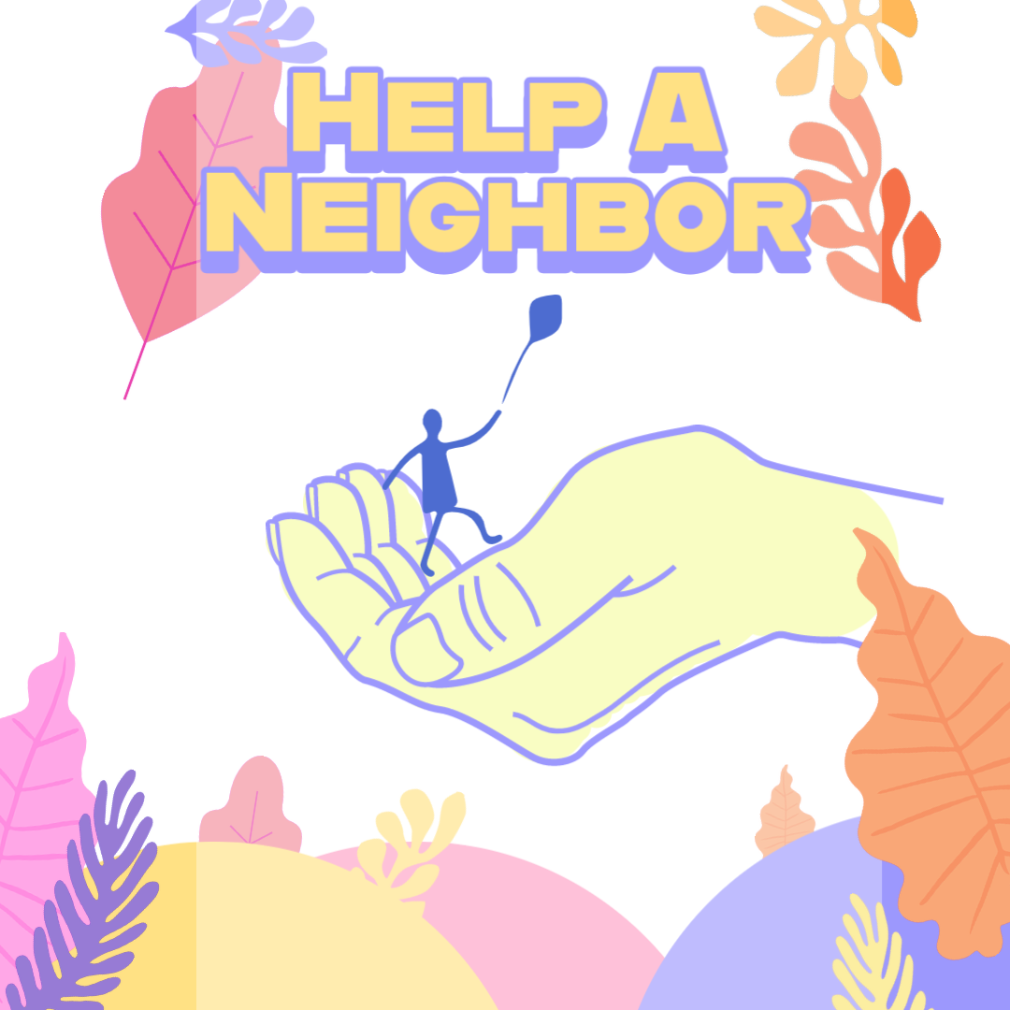
Help a Neighbor Drive
In partnership with families in need in your community, you award a local family with items they need during a difficult time.
How it Works: Sign up/Nominate at the web site and draw your winner once a month. Arrange to have a staff/street team member deliver the goods to the family in need and shows the heart of who we are as a station and as a body of Christ. Sometimes businesses are willing to partner to give what’s needed either financially or in man-power when it may be construction related.

Crystal Apple Award
In partnership with your local schools, you select a teacher of the month based on student or parent entries to your web site. You can present them with an actually Crystal Apple or a Certificate to celebrate their impact on their students, their school and the community.
How it works: Sign up/Nominate at the web site and draw your winner once a month. Arrange to have a staff/street team member deliver the trophy or certificate to the winner’s school with station swag. Sometimes schools will hold full assemblies to honor the teacher who has won. You could arrange to broadcast from the school, interview the teacher who won and while at the school record them doing the pledge of allegiance and air the next day. Tell them when and what time to listen which builds your audience and adds excitement about your station.
_____________________________________________________________________________________
Strategy
Picking one of these per quarter allows you to have a full promotions calendar and then the ones that work, build on them each year or swap for something else when the need arises.
These ideas may also spark promotions for your station and then share with other affiliates so we all win in building our audience and making a difference in the communities we serve.
Promotional mindset:
“Find a need & fill it; find a parade & get in front of it!”



